**Part 2 - Develop a proposal for Canada’s Innovation Ecosystem Development Strategy**

According to ISED (Innovation, Science and Economic Development Canada), innovation exists along a continuum and all strategies could be categorized into the below six aspects:

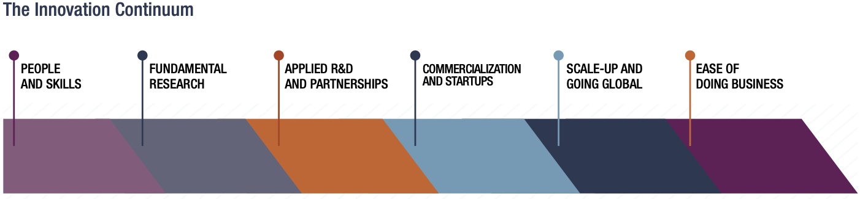

From part 1’s results, 10 countries’ innovation scores outperform Canada’s. They are: the U.S., Switzerland, Sweden, Singapore, Denmark, Netherlands, United Kingdom, South Korea, Germany, and Australia. Canada needs to study their strategies to improve its innovation ecosystem. Particularly instructive are South Korea, the United Kingdom, Germany, Sweden - countries with similar population sizes to Canada and comparable or even lower GDP per capita, yet achieving higher innovation scores.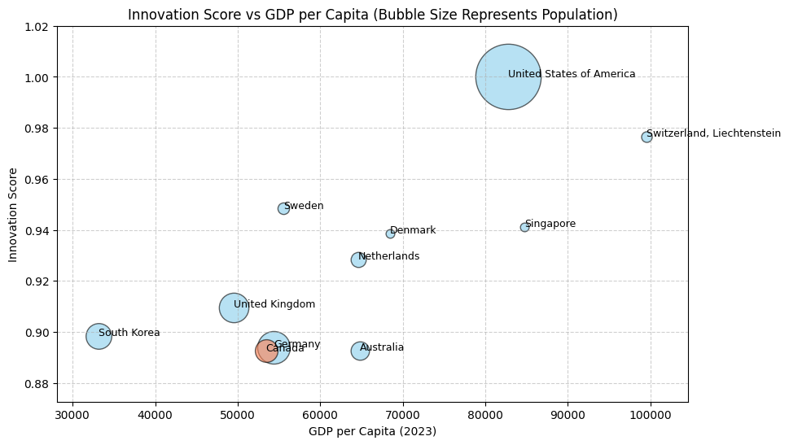

**People And Skills**

Canada could host more startup meetings and job fairs to enhance networking, facilitate knowledge exchange, and showcase innovative projects. This would help bridge the gap between talented professionals and suitable job opportunities.

In South Korea, COMEUP is an annual global startup festival started in 2019. The event features a variety of programs, including conferences, exhibitions, and investment opportunities, all designed to promote innovation and collaboration across borders. It provides a networking platform among entrepreneurs, investors, and industry leaders. (<https://www.comeup.org/en>)

Canada could also launch a dual-education program that combines practical, on-the-job training with theoretical education in a classroom setting. This program will arm underrepresented groups with the knowledge and skills to create, succeed, and take advantage of opportunities in the innovation economy.

First initiated by the German Federal Ministry of Education and Research (BMBF), this dual education program now covers over 300 professions including engineering, IT, healthcare, logistics, and skilled trades. Participants divide their time between companies for practical training and vocational schools for theoretical education, ensuring they develop both hands-on experience and relevant technical knowledge. Apprentices receive a monthly salary from their employers, with no minimum admittance requirements or compulsory employment prerequisites for applicants.

(<https://www.make-it-in-germany.com/en/study-vocational-training/training-in-germany/vocational/dual-system>)

**Fundamental Research**

Canada could start a long-term funding program to strengthen its international competitiveness of research at Canadian universities.

In Germany, Exzellenzstrategie (Excellence Strategy) is a federal and state government initiative designed to strengthen top-tier research and promote world-class universities in Germany. The program contains 2 funding lines: Clusters of Excellence and Universities of Excellence. Excellence Cluster supports collaborative research projects at universities, it focuses on interdisciplinary research and cooperation between universities and non-university research institutions.

On the other hand, Excellence Universities supports individual universities with outstanding research performance across multiple disciplines. The Wissenschaftsrat (WR, German Science and Humanities Council) will provide long-term funding for universities with approved development plans. In addition, researchers and universities enjoy a completely free choice of research fields and profile areas. (<https://www.exzellenzstrategie.de/en/what-is-exstra/>)

**Applied R&D and Partnerships**

Canada could widen the responsibilities of its ISED department, including collaborations with different government and public bodies, and industry experts to achieve a higher density of networks and clusters.

In the UK, the Department for Science, Innovation, and Technology (DSIT) works with multiple government agencies and public bodies. For example, it oversees several sub-organizations like the UK Research and Innovation (UKRI) and the Advanced Research and Invention Agency (ARIA). DSIT focuses exclusively on cutting-edge technologies like AI leadership and Satellite, it allocated £100 million for an expert task force to advance safe AI development in 2023. UKRI also established the National Satellite Test Facility (NSTF) to streamline and enhance satellite testing, consolidating various processes into a single hub in 2024.

(<https://www.gov.uk/government/news/initial-100-million-for-expert-taskforce-to-help-uk-build-and-adopt-next-generation-of-safe-ai>)

(<https://www.ukri.org/what-we-do/browse-our-areas-of-investment-and-support/national-satellite-test-facility/>)

ARIA was formally established in January 2023 and designed to fund high-risk, high-reward research projects. With an initial budget of £800 million, ARIA operates with significant autonomy to drive breakthrough innovations. (https://www.aria.org.uk/)

In addition, DSIT also provides a Science & Technology fellowship which is a 12-month part-time secondment bringing experts into DSIT, fostering knowledge exchange, policy training, and professional networking. (https://www.techuk.org/what-we-deliver/dsit-opportunities.html)

**ICT**

Canada can enhance its Information and Communication Technology (ICT) sector by investing in digital infrastructure and fostering innovation hubs that support cutting-edge research and development. This approach would bridge the gap between technological advancements and real-world applications, strengthening Canada’s global competitiveness in the tech industry. By prioritizing collaboration and sustainability, Canada can create a thriving ecosystem where innovation grows organically, benefiting both the economy and society.

A successful model for this can be found in Sweden, where Vinnova, the Swedish Innovation Agency, plays a key role in funding ICT research and driving digital transformation. Through initiatives like EUREKA CELTIC-NEXT, Sweden supports international collaborations in areas such as digital security, AI, 5G, IoT, and e-health. With an ICT score of 0.9403, Sweden demonstrates how integrating technology across industries—from healthcare to manufacturing—can create a balanced and innovative ecosystem. <https://www.vinnova.se/en/calls-for-proposals/eureka-cluster-financing/eureka-celtic-next-information-and-2023-04115/>

**Commercialization and Startups + Ease of Doing Business**

Canada could create an organization that is specifically dedicated to small and medium-sized enterprises in terms of commercialization and start-up. This will increase Canada’s competitiveness in commercializing new products and services and encourage innovators to take risks.

In Korea, the Ministry of SMEs and Startups (MSS) is established to promote business growth, foster business start-ups, and support micro-enterprises. Some of its policies include reforming micro-enterprise regulations, launching TIPS (Tech Incubator Program for Startups) to support commercialization, research and development (R&D), and export activities, and providing loans to SMEs for re-startup. (<https://www.mss.go.kr/site/eng/main.do>) In addition, as mentioned before, In 2024, Korea’s COMEUP event also featured the "COMEUP STARS" program, which selects and supports promising startups through mentorship, business matching, and pitching opportunities. This initiative aims to provide early-stage startups with the resources and exposure needed to succeed in the competitive global market (<https://www.comeup.org/en>).

Similarly, In the UK, the Regulatory Innovation Office (RIO) was introduced in 2024 and aims to cut short regulatory processes and accelerate the deployment of innovative technologies across various sectors, including Engineering biology, Space, AI, and Connected and autonomous technology. (<https://www.gov.uk/government/news/game-changing-tech-to-reach-the-public-faster-as-dedicated-new-unit-launched-to-curb-red-tape>)

**Scale-up and Going Global**

Canada could introduce an International Growth Program to help medium-sized companies expand their presence in global markets. This initiative would also enhance access to late-stage capital, enabling Canadian firms to scale more effectively.

In Korea, ​The Export Voucher Program provides selected SMEs with financial support through vouchers (ranging from 20 million to 200 million Korean won) to aid in global expansion, thereby promoting overseas growth and increasing domestic employment. The government typically covers 50 to 70 percent of the costs associated with the selected services, with the remaining portion funded by the participating companies.

(<https://www.investkorea.org/ik-en/bbs/i-465/detail.do?ntt_sn=492747>)

**Global Country Development & Prosperity Index**

Canada has the potential to strengthen its Global Country Development & Prosperity Index by enhancing its social welfare programs and prioritizing sustainable development. By aligning economic growth with social well-being, Canada can ensure a higher quality of life for its citizens, fostering a more equitable and prosperous society. This balanced approach would not only address immediate needs but also lay the groundwork for long-term resilience and inclusivity.

A natural example of this can be seen in Sweden, where the government places a strong emphasis on healthcare, education, and social equality. Sweden’s tax-funded healthcare system guarantees universal access to essential services, significantly contributing to the well-being of its population. This commitment to social welfare has resulted in remarkable achievements in quality of life, public health, and educational attainment, setting a benchmark for other nations.

<https://sweden.se/life/society/healthcare-in-sweden>

<https://www.imf.org/external/pubs/nft/2003/sweden/index.htm>

Similarly, Germany’s Sustainable Development Strategy demonstrates how environmental sustainability can go hand-in-hand with economic growth. By aligning with the United Nations’ 17 Sustainable Development Goals, Germany focuses on climate protection, renewable energy, and sustainable urban development. The country’s ambitious targets, such as reducing greenhouse gas emissions by 65% by 2030 and achieving neutrality by 2045, alongside its push for a circular economy, reflect a deep commitment to sustainable practices. Canada can draw inspiration from these models to create a harmonious balance between economic progress, social welfare, and environmental stewardship.

<https://sustainabledevelopment.un.org/memberstates/germany>

<https://www.sgi-network.org/2024/Germany/Economic_Sustainability>

**Economy Freedom Index**

Canada has the opportunity to enhance its Economic Freedom Index by reducing regulatory burdens and streamlining business processes, creating a more competitive and innovation-driven economy. By cutting bureaucratic inefficiencies and simplifying regulations, Canada can attract greater investment, encourage business expansion, and ultimately fuel sustainable economic growth. This approach would not only improve the ease of doing business but also foster an environment where innovation can thrive, benefiting both industries and consumers.

A compelling example of this strategy can be seen in the United Kingdom, which launched the Regulatory Innovation Office (RIO) in October 2024. The RIO aims to accelerate the approval and deployment of emerging technologies by removing unnecessary regulatory barriers. Focused on high-growth sectors such as artificial intelligence (AI), engineering biology, space, and autonomous technologies, the initiative ensures that innovative businesses can bring their products and services to market more efficiently. By addressing regulatory inefficiencies, the UK is enhancing its economic competitiveness while maintaining strong consumer and environmental protections. Canada can draw inspiration from this model to strike a balance between fostering innovation and ensuring accountability, creating a dynamic and resilient economic landscape.

<https://www.gov.uk/government/news/game-changing-tech-to-reach-the-public-faster-as-dedicated-new-unit-launched-to-curb-red-tape>

**Unicorn Count**

Canada has the potential to significantly increase its Unicorn Count by boosting venture capital funding and cultivating a supportive ecosystem for startups. By bridging the gap between early-stage ventures and global success, Canada can foster the growth of more billion-dollar companies, driving innovation and economic prosperity. A thriving startup environment, supported by accessible funding and mentorship, would position Canada as a leader in the global tech landscape.

A compelling example of this approach can be found in the United Kingdom, which has built a robust venture capital ecosystem leading to a flourishing tech industry. As of recent data, the UK has produced over 150 unicorns, accounting for a third of Europe’s billion-dollar startups. Remarkably, more than 40% of these unicorns emerged in the last three years, highlighting the rapid growth and dynamism of the UK’s tech sector. London, often regarded as the 'fintech capital of Europe,' is at the heart of this success, hosting approximately 74% of the UK’s unicorns, including prominent fintech companies like Monzo and Revolut. Beyond venture capital, organizations such as Tech Nation are critical in nurturing startups by providing mentorship, networking opportunities, and funding avenues. By drawing inspiration from the UK’s model, Canada can create a vibrant startup ecosystem that empowers entrepreneurs and accelerates the rise of its unicorns.

<https://www.great.gov.uk/international/investment/sectors/technology/>

<https://www.beauhurst.com/research/unicorn-companies/>

<https://technation.io/>

